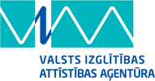 | NORDPLUS projekts  „Studēt vai strādāt?”  („To study or to work?”)  projekta nr.  NPJR-2014/10407

Latvia | Lithuania
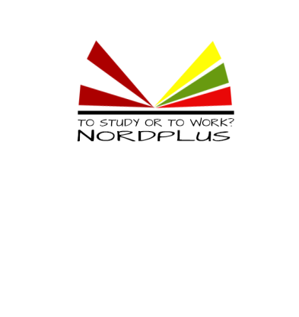  Nr. 1 | 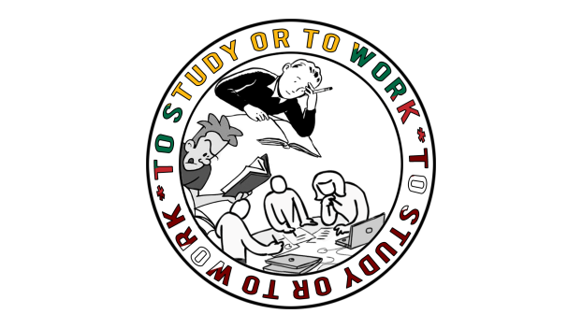  Nr. 2
Beate Švāne
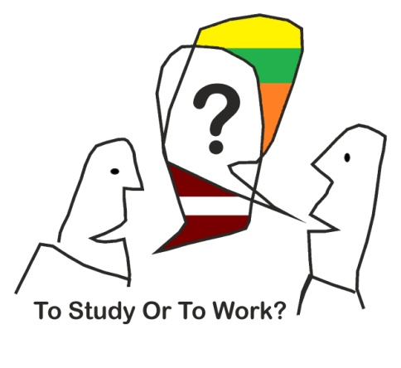  Nr. 3 | 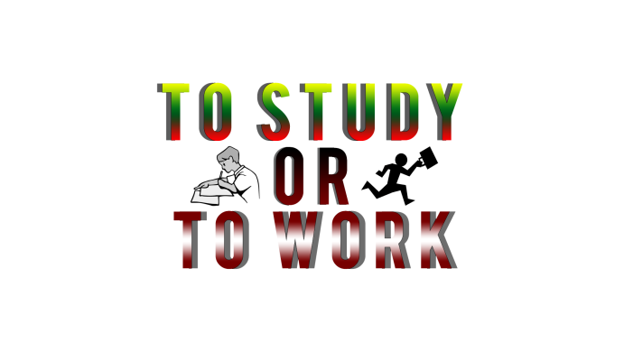  Nr. 4
Rihards Juris Bērziņš | Rytis Kuzas
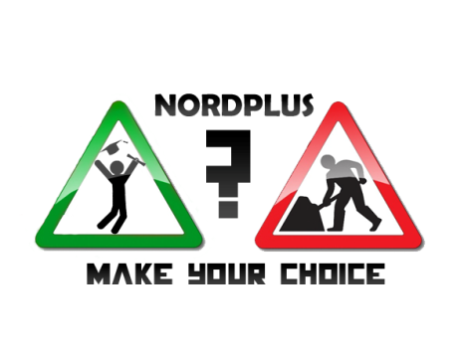  Nr. 5 | 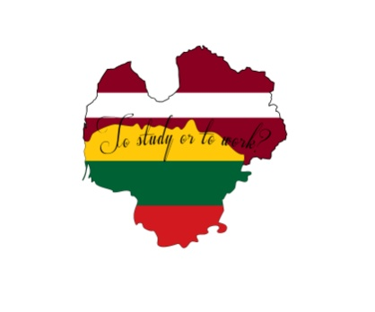  Nr. 6
Sandijs Bečis

The LOGO results from Lithuania and Latvia are:
 | Lithuania | Latvia | Lithuania +Latvia
Nr 1 | 23 – 18.4% | 22 - 22.7% | 45 -20.3%
Nr 2 | 27 – 21.6% | 15 – 15.5% | 42 - 18.9%
Nr 3 | 5 – 4% | 8 - 8.3% | 13 - 5.8%
Nr 4 | 43 - 34.4% | 16 - 16.4% | 59 - 26.6%
Nr 5 | 14 - 11.2% | 20 - 20.7% | 34 – 15.4%
Nr 6 | 13 - 10.4 | 16 - 16.4 | 29 – 13%
Respondents | 125 | 97 | 222

1st place -

Project LOGO is:

Logo creator: Rytis Kuzas, Lithuania

